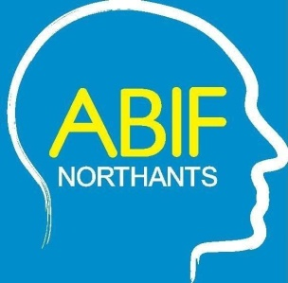

Northamptonshire Acquired Brain Injury Forum FREE Seminar

The use of Technology and Artificial Intelligence to support people living with acquired brain injury

Wednesday 25th November 2026
Corn Market Hall, London Road,
Kettering NN15 7QA




SEMINAR PROGRAMME

The Northamptonshire Acquired Brain Injury Forum are pleased be holding this FREE seminar entitled, “The use of Technology and Artificial Intelligence to support people living with acquired brain injury”, where speakers will share their experience and their work with technology & AI for supporting life after brain injury, exploring the positives and negatives of this digital revolution.

9.30 Arrival, Registration and Coffee

9.55 Introduction to the day – Dr Keith Jenkins, Chair of Northamptonshire Acquired Brain Injury Forum
10.00 Using Artificial Intelligence to provide reliable information and support for people after acquired brain injury – Andrew Taylor, Head of Digital, Headway UK

10.40 Lived experience of putting technology to work after brain injury - TBC
11.10 Coffee/Tea and networking opportunity
11.40 Developing and using an application to support life after brain injury, Neumind – Ellis Parry, CEO
12.20 Lived experience of putting technology to work after brain injury - TBC
12.50 LUNCH
1.30 Virtual Reality and how it can be used successfully after brain injury – Rebecca Gill, VR Therapies
2.10 It can be dangerous out there, keeping safe whilst using technology & AI – Jeff Goodright, Cyberspider
3.40 Close

To attend this free seminar, please complete the booking form and send to Julie Allsopp julie.allsopp@oakleafcare.com to reserve your place

